
The COVID-19 vaccine is being offered to your child. Your child will receive their first COVID-19 vaccine and you may be notified about the second dose later. Further information can be found on the DfE website: https://www.gov.uk/government/publications/covid-19-vaccination-resources-for-children-and-young-people Please discuss the vaccination with your child, then complete this form by Monday 20th September. Information about the vaccinations will be put on your child’s health records.
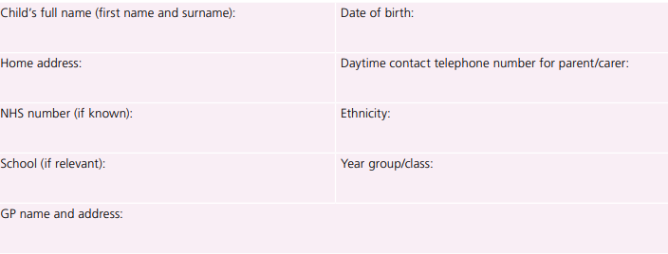
Does your child have any medical conditions? Please list them here or write N/A if they do not have any

Does your child take any medication? Please list any medications here or write N/A if they do not take any

Does your child have any allergies? Please list them here or write N/A if they do not have any

Has your child had COVID-19? If yes, please give the date of the positive result


